**MIS 273 Assignment to install Windows Server**

**Project Name:  Server Installation**  **Name:** ___ETHAN DUNZER_________

Read this entire document before starting your Windows Server installations

**Virtual Machine Infrastructure:**

VMware or VirtualBox, or Hyper-V (You can use whatever virtual machine environment you choose. However if you haven't used any of these before, it is recommended that you use VirtualBox which is what the provided video(s) will cover. It is not required that you use a virtual machine. You could install Windows Server on its own computer or in a dual boot setup. However, it is recommended that you get the practice in a virtual machine environment since most functioning Windows servers in industry are virtual machines.)

**Design:**

The goal of your first lab is to become familiar with the installation of Windows Server 2016 or Windows Server 2019. The textbooks cover Windows Server 2016. There are some differences/additions in Server 2019. However the vast majority of features are pretty much the same. It should be fine to install either Server 2016 or Server 2019 for now.

**Important Note:**

At this stage in the course we are just beginning to think in these terms.  The goal of this exercise is not to focus on specifics, but rather to get us thinking about potential designs and their relative tradeoffs in both the short and long term within the context and scope modern day server operating systems.

**Major Steps:**

Follow the video supplied on Canvas when performing the installation. The two steps below are covered in the video.

(1.) Obtaining and installing VirtualBox as the recommended Virtualization software. You can use other virtualization software such as VMware or Microsoft Hyper-V if desired.

(2.) Obtaining the Windows Server ISO image and installing Windows Server. You do not need a key in order to do a test install (i.e. 180 days). You’ll install Server twice as described below.

(3.) Answer the following questions.

**After completing the installation answer these questions:**

1. What differences do you notice between installing a Windows Desktop OS like Windows 10 vs. a Windows Server OS (with Desktop Experience)?

Its very similar but there are accouple differences. If I recall correctly Windows 10 has a lot more questions during the installation, Windows server is very straight forward just create a user account and go.

1. What are some common applications that you expect organizations will run on Windows Servers?

I’m guessing that normal windows programs and apps will be run because they are so integrated, but also the ability to run simple print, domain control, and web server applications is likely.

1. What are some of the advantages and disadvantages to running an operating system like Windows Server 2016 in a Virtual Machine (VM) compared to installing it directly on the computer?

The biggest is that you don’t have to dual boot, or switch between different operating systems. Another is to keep everything separate and limit the possibility of data corruptions, or other potential problems. You can also control system resources.

**Deliverable(s):**

Document your installation steps as part of this assignment by pasting a few screen prints into this document. Save your answers to the 3 questions above and screen prints and save them as a Word or PDF document. Submit and upload that document to Canvas in the assignment area for this project.

**Installation Information:**

You can download Windows Server ISO from Microsoft Azure. However at this point a 180 evaluation copy is recommended for your first server install. The provided video on installing VirtualBox and Windows Server shows how to get a trial version of Windows Server. This allows you to save you Windows Server Azure copy for use at a later date.

Here are some details you'll want to know as using the video provided to perform the install:

1. The video says to choose Windows Other 64 bit to install Windows Server 2019. However, the most recent version of VirtualBox allows you to choose Windows 2019 64 bit. Of course this assumes that you have a 64 bit processor.

2. When choosing where to find the iso file on your own computer after you've downloaded it, you may have to click on the Add button in order to browse to the folder where the iso file is located.

3. You'll be provided the following version options to install. I want you to install two versions of Windows Server for this assignment.

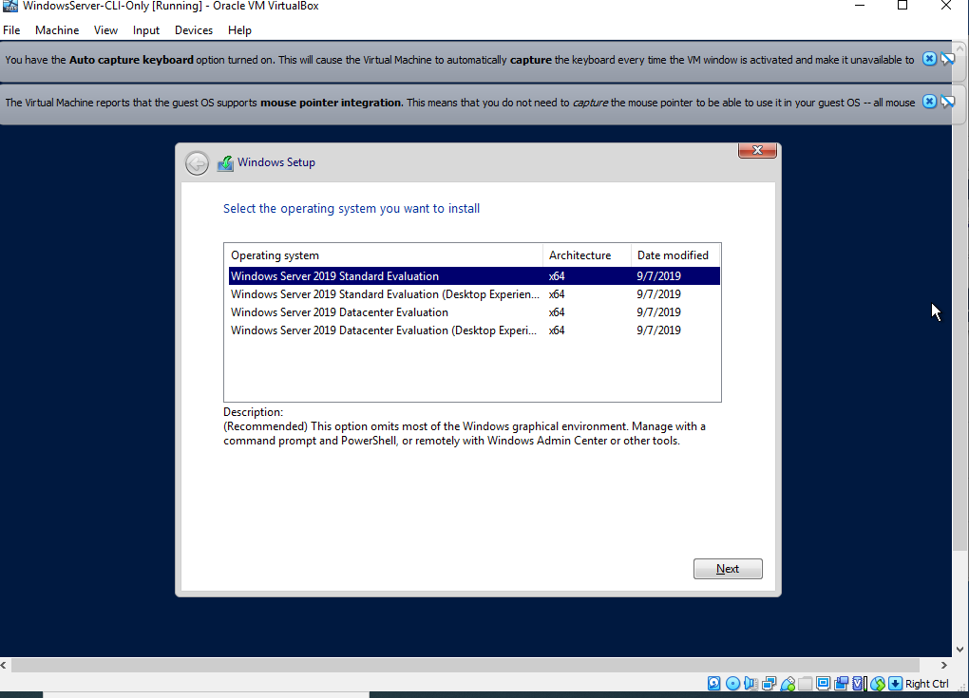

For the first install choose Windows Server 2019 Standard Evaluation (Desktop Experience). This gives you a version of the server with a graphical user interface.

After finishing the first install, choose Windows Server 2019 Standard Evaluation to install a second version. This second installation will provide a command line interface from which to work. Just click on New again in VirtualBox to start a second installation. To shutdown the server after you get it up and running you may have to scroll down to see the typical Windows Start menu where you can click on the button labeled Power.

At the end of the second (command line interface) install when it asks to create and confirm a password you may have to use the Tab key after entering the password the first time to move to the Confirm line. After entering the password on the Confirm line use the Tab key again to finish the process.

We will be configuring the Server installations in later assignments. For this assignment there is no need to do anything other than complete the installs, answer the questions in this document and provide screen prints of both Windows Server installations below:

Paste screen prints here.

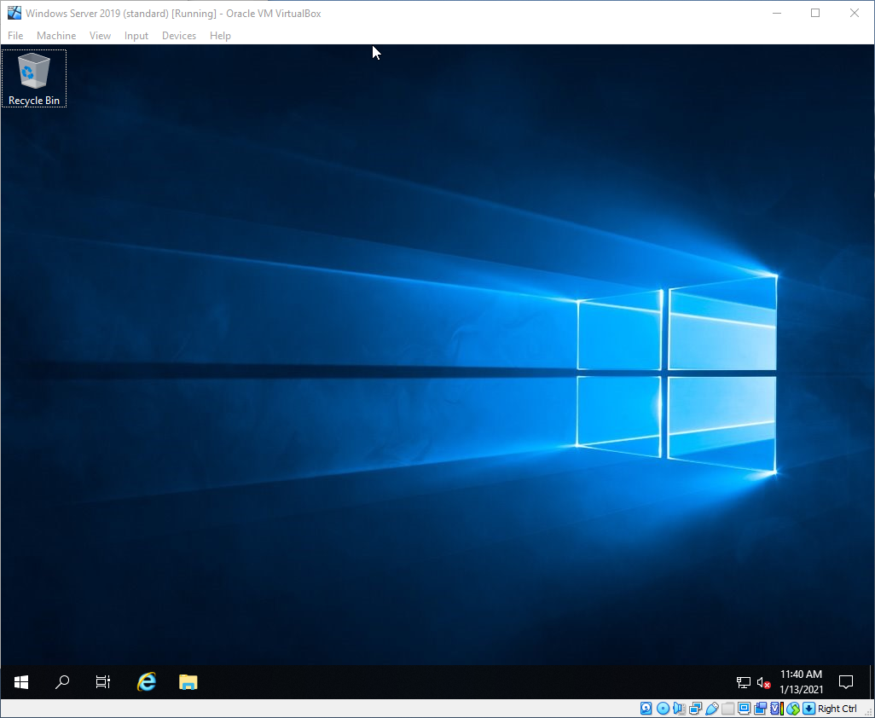

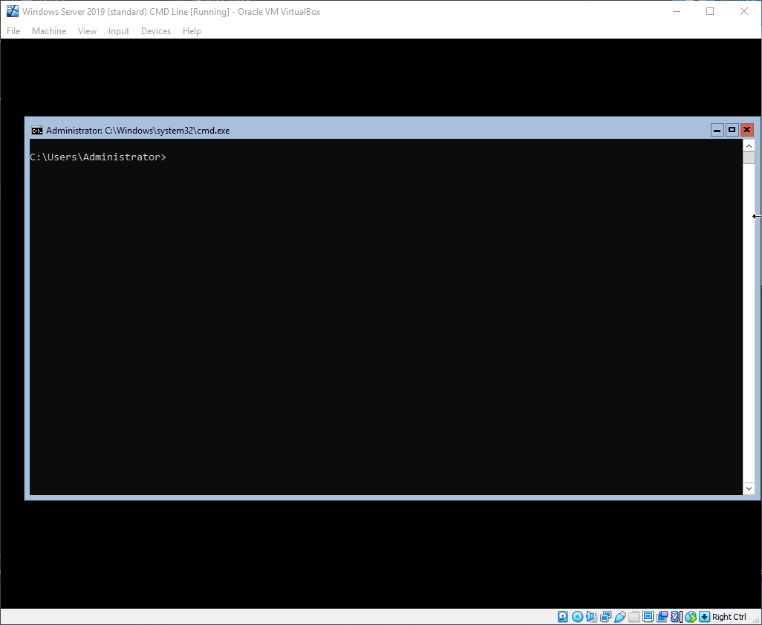

Here’s information regarding accessing the Microsoft Academic Software resources that are on Azure, if you want to obtain Server 2019 from there. Remember though it is recommended that you just use the 180 day trial version shown in the video for this assignment.

Logon via:

[https://Azureforeducation.microsoft.com/devtools](https://azureforeducation.microsoft.com/devtools)

Select personal when asked what type of email address they want to use.

Enter your OIT.edu Email address.

Under: Education - > Software

Select the: Heading (located just under Quickstart (in blue) and above Learning (in blue)).

Or use the search box to find what you're looking for.

If using your Azure copy of Windows Server:

Locate the ISO Image for Windows Server (Standard).

(Select:  Windows Server, during installation, use your installation in evaluation mode - i.e. do not use your key).

Note: Save the key that you receive for your later long term use.